Healing Art Design & New Age Gallery, Kingscliff

A light port hole activated for those in search of spiritual healing, to find one’s soul purpose, lessons, gifts, talents and mission in life.
- Art of High Colour Vibration Energy for upliftment, balance, peace and healing the mind, body and soul!
- Spiritual services to awaken mankind to a higher plane of awareness.

Kingscliff

Sylvia Meissner works as an international artist, professional psychic and healer. Her beautiful and unique Holistic Healing Centre, only 36 minutes from Bryon Bay, is located opposite the Cudgen Surf Life Saving Club, facing the healing powers of the ocean.
Empower your inner being as you go on a journey of colour healing and connection through Sylvia’s channeled artworks that adorn the gallery walls.
Spiritual Services include psychic intuitive readings and healing services offered by Sylvia, including chakra balance through reiki, crystal and pranic healing, auric clearing sustaining correct energy flow for the body, cutting past cords and confronting/altering negative mind set patterns. Browse the great range of products – chakra spray mists, aromatherapy, wearable energies, crystals, handmade Swarovski suncatchers, boho art pouches, art prints and much more!
Healing Art Design & New Age Gallery
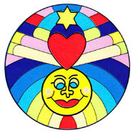
Shop 2B, 60 Marine Parade, Kingscliff, NSW, 2487

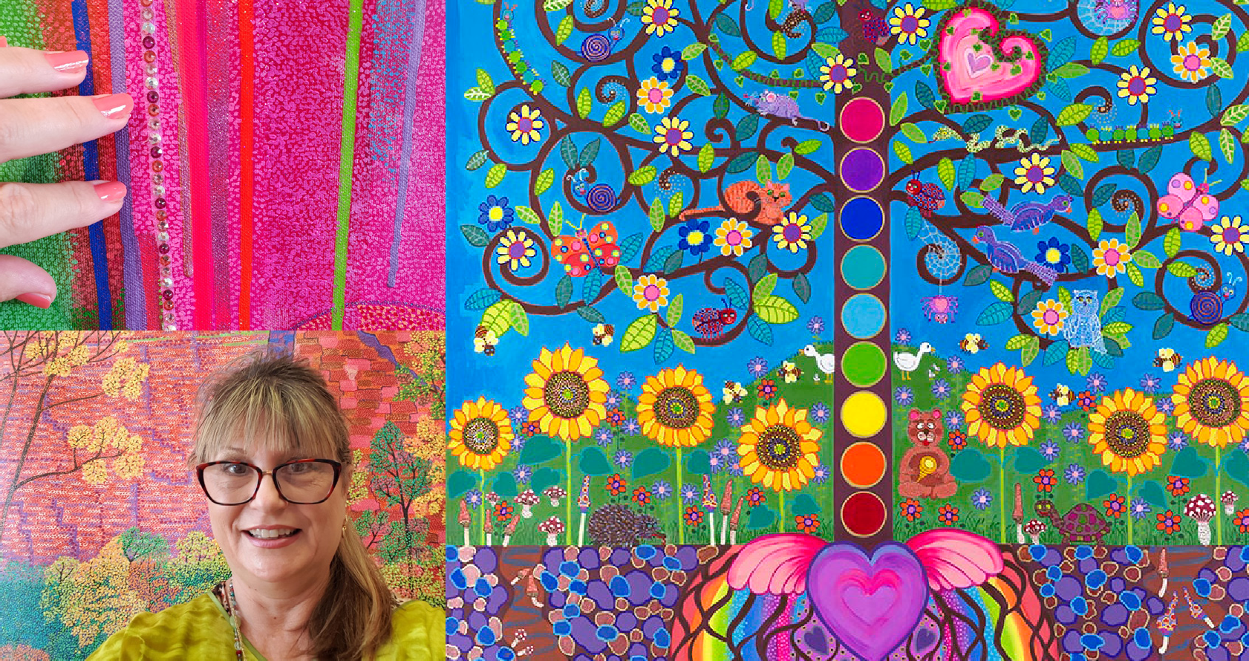
0408 868 793
healingartdesigns@bigpond.com www.healingartdesign.com
healingartdesigns healingartdesign88
HEALING ART DESIGN
& NEW AGE GALLERY

